Jefferson’s bedroom and study

"But whether I retire to bed early or late, I rise with the sun."  
- Thomas Jefferson to Dr. Vine Utley, March 21, 1819

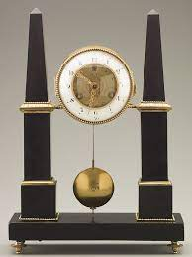A typical day for Jefferson started early. He told of a fifty-year period in which the sun had never caught him in bed; he rose as soon as he could read the hands of the clock kept directly opposite his bed. He designed it so he could wake up and go to either his bed chamber or his study. Which side of the bed he got up on depended on whether he was going to relax or work. (You wonder how often he got up on the wrong side of bed.) That little thing on the wall at the foot of the bed reflects the sun's light. This made it so that the sun would shine directly on his face in the morning, waking him up.

Thomas Jefferson liked alcove beds, but his bedroom in Monticello didn't have a suitable wall, so he converted a doorway into an alcove.

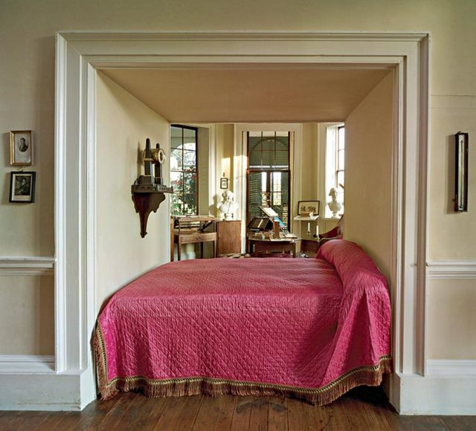

He introduced the alcove bed into the redesign of Monticello that he began in the 1790s. He admitted his partiality for this spatial arrangement in a letter to [James Madison](https://www.monticello.org/site/research-and-collections/james-madison): "Indeed I varied my plan by shewing what it would be with alcove bedrooms, to which I am much attached." He included recesses in the interior walls of all the new bedrooms; however, in his own [bedroom](https://www.monticello.org/site/research-and-collections/bed-chamber) which was located in the older portion of the house, it was necessary to augment an already existing wall in order to accommodate a bed alcove. He chose the interior wall separating what would become his bed chamber and his [study](https://www.monticello.org/site/research-and-collections/cabinet), centered the alcove on an existing doorway, and built it out into the larger of the two rooms to create the alcove. He placed a new doorway at the foot of the alcove.

Aside from the [alcove bed](https://www.monticello.org/site/families-and-teachers/personal), open on both sides, joining the bedroom with Jefferson's [Cabinet](https://www.monticello.org/site/visit/crossroads), or office, the architectural features of his bed chamber include the following: a [privy](https://www.monticello.org/site/house-and-gardens/rooms-and-furnishings), located near one end of the bed, an early example of indoor bathroom facilities in America; one of the house's thirteen skylights; and a [closet](https://www.monticello.org/site/research-and-collections/bedroom-portholes) over the bed, which utilizes space efficiently and is accessible via ladder.

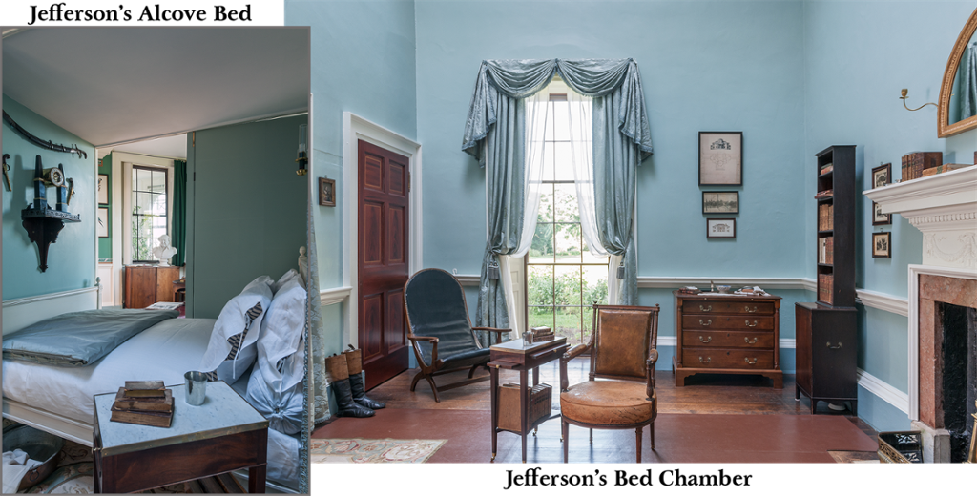

## Record Keeping and Morning Preparations

After arising, Jefferson measured and recorded the temperature, the direction and speed of the wind, and the amount of precipitation. He made note of the weather and other indexes of climate, such as the migration of birds and the appearance of flowers, throughout his life. He shared his records with others in the hope of creating a national database of meteorological information.

Once he had recorded these notes, he started his own fire and soaked his feet in cold water. He maintained the foot bath for sixty years and attributed his good health in part to this habit.

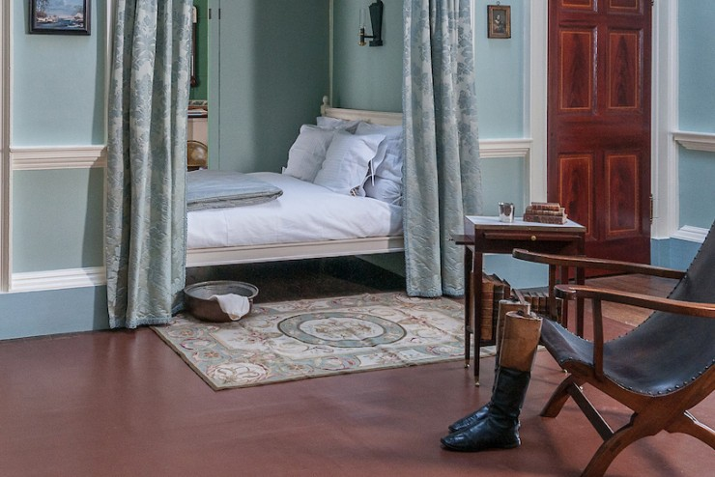

Following his morning routine, Thomas Jefferson settled into a lengthy period of letter-writing: "From sun-rise to one or two o'clock," he noted, "I am drudging at the writing table." Jefferson wrote almost 20,000 letters in his lifetime, among them scholarly musings to colleagues, affectionate notes to his family, and civil responses to admirers. He wrote John Adams that he suffered "under the persecution of letters," calculating that he received 1,267 letters in the year 1820, "many of them requiring answers of elaborate research, and all to be answered with due attention and consideration.

**A Modern Office**

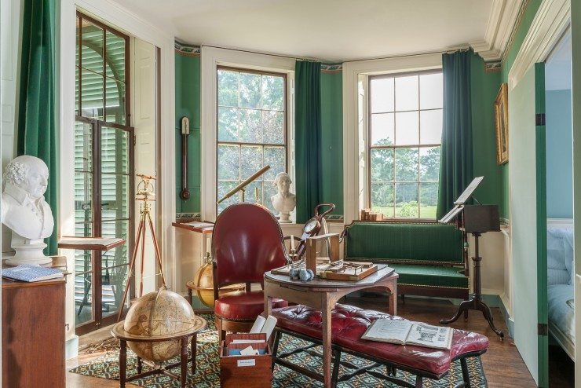

Jefferson researched and wrote these letters in what has been called the earliest modern office. His Cabinet was, in contemporary language, "user-friendly." He filled it with devices designed "with a greater eye to convenience," including what might be called a "database" today: a revolving bookstand, probably of Jefferson's own design. He maximized the Cabinet's lighting by using large windows and French doors designed to capture the full southern exposure. Candlesticks attached to the arms of his chair gave him further light.

Finally, Jefferson had at hand the ultimate office necessity, a copying machine. He was enraptured by copying devices and called them "the finest invention of the present age." He used them to make duplicate sets of his letters, which he kept in filing presses, tying them into bundles organized alphabetically and chronologically. This arrangement allowed Jefferson to pinpoint the location of any given letter, and even send for a particular one when he was away from Monticello. He owned several styles throughout his life, and his favorite was the Polygraph. The device holds two sheets of paper and two connected pens, so that as Jefferson wrote with one pen, the other pen followed to make an exact copy.

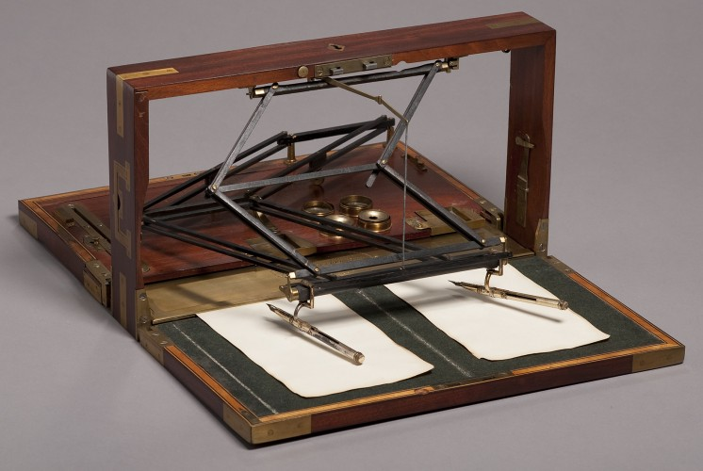

Jefferson often tinkered with others’ inventions to improve them. This polygraph was created by John Isaac Hawkins in London and many models were shipped to America. Jefferson and APS Member Charles Willson Peale corresponded frequently about ways to improve Hawkins’ original design. Jefferson moved the inkwells for easier access while writing.

Interested in every branch of applied science and math, Jefferson corresponded with scientists around the world. He was very clear on his view of technology: “Science is more important in a republican than in any form of government.” The freedom of ideas, he believed, would lead to a better and more comfortable life for the entire populace instead of for “the few” as in a monarchy. So he was very keen on such practical inventions as his Polygraph.